SmartCare v0.3 - Domain Model Workbook
Week 6 student resource

Requirements Review
Nouns:
- Staff
- Patients
- Management
- Bookings
- Appointment Status
- Appointment History
- Practitioners
Verbs:
- Report
- Uses
Business Rules:
- Small
- Maintainable
- System

Requirement-to-Concept Trace
Requirement | Concept | State/behaviour | Decision
System shall be maintainable and easy to support | Simplicity | System will only focus on necessary functions. | Keep the scope small
Manage appointment Status | Be able to view and manage the status of an appointment | If an appointment has been changed then the status will reflect that. E.g. appointment canceled. | Give each appointment a status value and be able to update and check.
View Appointment History | Store the appointment history of a patient | Staff can view the appointment history of a patient when needed. | Each patient will have a list that stores their appointment history.
Manage patient bookings | Patients will be able to manage their own bookings. | If a patient books or cancels an appointment the application will update with that information. | Create tools to allow patients to place and cancel bookings.
Eliminate duplicate bookings | Make it impossible for the program to receive a duplicate booking | If the booking has been booked make it unavailable for anyone else to book it. | Create a system that manages what bookings are available.
Display patient information | Ability to retrieve the patient information | Staff can view information about the patient when needed. | Create a system to return all information about a patient.
View practitioner availability. | Practitioners can indicate when they are available. | When a practitioner updates their availability, the program will reflect that information. | Create a system for practitioners to manage their timetables.

CRC Cards

Patient
Responsibilities | Collaborators
Stores and displays information about the Patient. E.g. Name, Age, Date of Birth. | Practitioner
Allows patients to update information. | Appointment

Practitioner
Responsibilities | Collaborators
Stores and can display information about the Practitioner. E.g. Name, Age, and Availability | Patient
Allows the program to know when the Practitioner is available. | Appointment

Appointment
Responsibilities | Collaborators
Allows patients and staff to view available and booked appointments. | Practitioner
Allows staff to change the appointment status. | Patient

Optional class – Clinic
Responsibilities | Collaborators
Would allow the program to know which clinic it is currently accessing. This class would only be introduced if the program was expanded to support multiple clinics | Patient, Practitioner
Returns information for that clinic | Appointment

UML Class Diagram
Insert/draw UML here. Include defensible relationships and multiplicities.
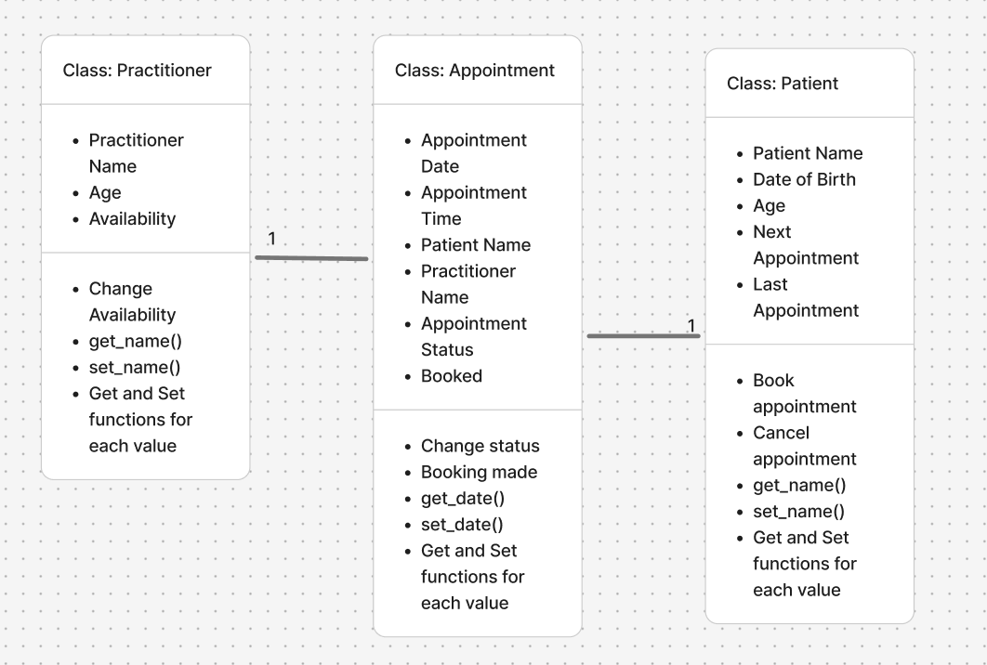

Design Rationale
Explain class selection, responsibility allocation and key relationships.
Practitioner, Appointment and Patient would be the three main classes for this program. An additional class that could be added is the clinic class. This class only would need to be added if the program was expanded to support multiple clinics. The practitioner and patient classes would both be associates of the appointment class. This is because appointments would need a patient and a practitioner needed to be an appointment. Each appointment would only have 1 practitioner and 1 patient.

AI Design Review Record
AI suggestion | Evidence | Decision | Reason | Model change
Create Patient Class | Store patient information, allow staff to find patient information | Accept | Patient data must be stored and searchable. | Add patient class
Create Practitioner Class | Store practitioner information | Accept | Practitioner details are required for appointment management. | Add practitioner class
Create Appointment Class | Manage appointments, prevent duplicate appointments, support appointment status tracking, maintain appointment history | Accept | Appointment data is important for the ability to schedule appointments, track the status, and keep appointment history | Add appointment class.
Add Billing class | No confirmed requirement | Reject | Billing management is not mentioned in the requirements | No change
Duplicate booking prevention through appointment | Prevent duplicate bookings | Modified | The prevention of duplicate bookings is mentioned. | Create a function to ensure no duplicate appointments are made.

Reflection
The hardest modeling decision was figuring out what information is needed for each class. When designing the class I would constantly overlook what information should be given to the patient class. An example of information I overlooked was a value to store the patient phone number. AI over-designed by suggesting functionality that is outside of the scope of the application. The evidence that supported my final choices were what I could figure out was needed based on the brief provided .

